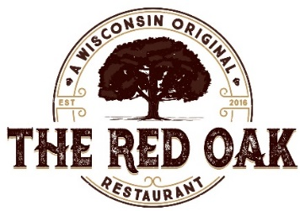

Kid’s Menu

Chicken Tenders 9
Chicken Tenders from Bell & Evans all white meat chicken breast
Served with house made applesauce & choice of house fries or vegetable of the day

Grilled Cheese Sandwich 8
Wisconsin Cheeses served on Wild Flour Bakery country bread with real butter for grilling
Served with house made applesauce & choice of house fries or vegetable of the day

*Kid’s Grass-Fed Burger 10 Add Cheese 1
Pasture raised 4oz beef burger, served on warm Wild Flour Bakery buttered bun
Served with house made applesauce & choice of house fries or vegetable of the day

Wisconsin Beer Battered or Baked Cod (Friday Night Only) 10
1 piece served with house made roasted applesauce & twice cooked fries

House Fries: Hand cut & cooked in GMO free rice bran oil

Brunch Items Available Sunday 9am-2pm

French Toast 5
Home made French toast made with local eggs and Wild Flour bread, served with real Wisconsin
maple syrup and butter

One Egg with Roasted Potatoes 7
One local, cage free egg your way
Served with toasted Wild Flour country bread & roasted potatoes with seasonal vegetables

**Consuming raw or undercooked meats, poultry, seafood, shellfish, eggs or unpasteurized milk may increase your risk of foodborne illness.

